Welcome to the 2019 NEWCRC 7’s Conference Championship, hosted at Babson College. Over the course of the day we will be crowning our Men’s & Women’s conference champions, and granting those clubs our Automatic Qualifier designation into the USA Rugby 7’s National Championship.

Babson Field Supervisors will be present at each location to direct you and answer any questions that you may have regarding navigating the Babson campus.

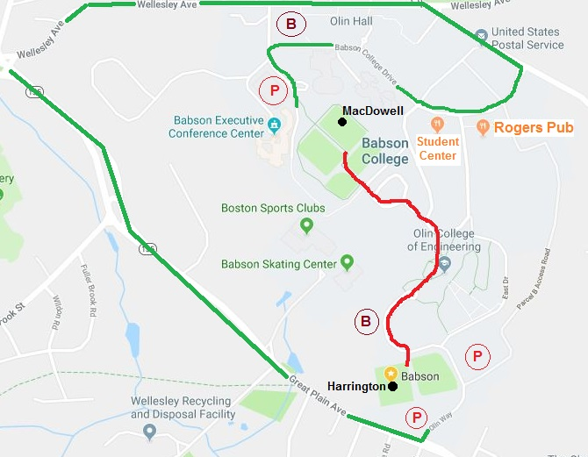
Getting Around Campus
Babson Field Supervisors will be present at each field to help direct you wherever you need to go. Moving between fields, you may take the walking route marked in RED on the map (0.5 miles, with a hill) or the driving route marked in GREEN (2 miles).
Unfortunately, due to town regulations, traffic gates will be closed at various points around campus. The GREEN route ensures that you are not restricted by these gates, and is the fastest option for those traveling between fields by vehicle.

Parking
Parking is available within a short walk of each field. Cars may park in lots designated by “P” on the map above. Overflow lots are marked by a “B”. Buses must park in the “B” lots.
Guests at Harrington can use Lot D or Lot C (“P” lots on the map), with overflow Lot A (“B” lot) at the top of the hill
Guests at MacDowell can use Upper Deck Lot (“P” lot on the map), with overflow Knight Lot (“B” lot) adjacent to Babson College Dr.

Restroom Facilities
Guests at Harrington will have access to portable toilets immediately adjacent to the field.
Guests at MacDowell will have access to portable toilets immediately adjacent to the field. Indoor facilities can be found at Webster Athletics Complex nearby.
Additional indoor facilities can be found in the Reynolds Student Center marked on the map.

Food Options
On-Campus there are two options for food;
- Reynolds Student Center contains a Dunkin Donuts in addition to a cafeteria-style restaurant with hot and cold prepared foods, as well as pre-packaged food options.
- Rogers Pub is a family friendly bar & grill with a large dining area and a simple food menu.
Off-Campus there are plenty of options for food, including;
- Volante Farms is a market with a full service deli, produce, and more. 1-mile from Babson.
- The Local is a family friendly restaurant with a full menu. 2-miles from Babson.
- Comella’s is a small pizza place with limited dine-in seating. 2.5-miles from Babson.
We are trying to have concession tables set up at each field, however Babson’s administration has a very restrictive “vendor” policy which may prevent that from happening. Please plan to bring your own snacks, or to visit one of the options listed above for lunch.

Full Schedule
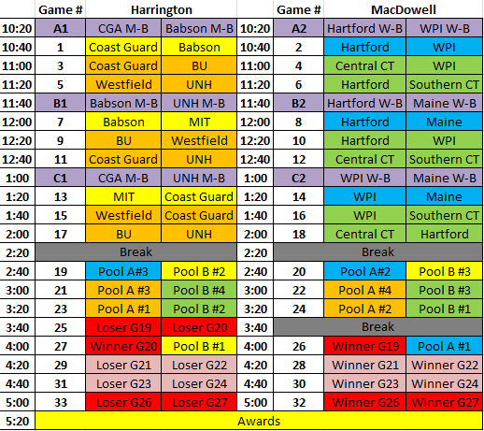
Pool A Pool B  Coast Guard Southern CT  BU Hartford  Westfield WPI  UNH Central CT  Men’s Pools | Pool A Pool B  Maine Coast Guard  Hartford Babson  WPI MIT  Women’s Pools

B-Side matches designated by letters & purple shading

Men’s Bracket
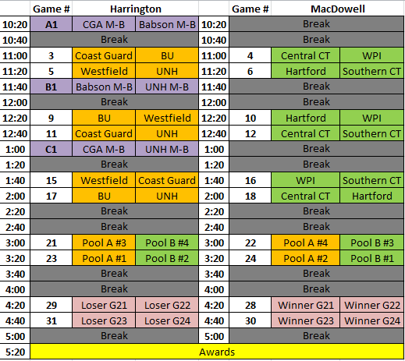

B-Side matches designated by letters & purple shading

Pool A | Pool B
Coast Guard | Southern CT
BU | Hartford
Westfield | WPI
UNH | Central CT

Women’s Bracket
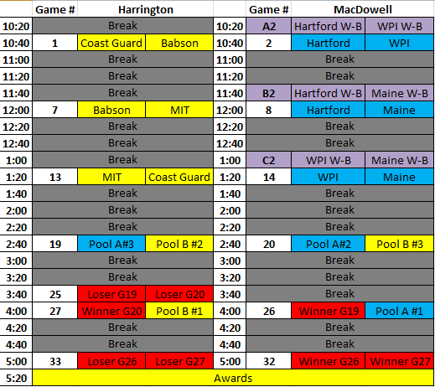

B-Side matches designated by letters & purple shading

Pool A | Pool B
Maine | Coast Guard
Hartford | Babson
WPI | MIT

Pool Standings & Tiebreakers
Pool standings will be determined by “Tournament Points” (Win = 3 points, Tie = 2 points, Loss = 1 point). Should there be a “Tournament Point” tie at the conclusion of Pool Play, the following tiebreakers will be implemented, in the order listed below;
- Head to head record
- Point differential (points scored for, minus points scored against)
- Tries scored differential (# tries scored, minus # tries scored against)
- Coin toss
Extra Time Policy for Playoff Rounds
During the playoff matches only (Consolation & Championship round), in the event of a match being tied at the end of normal time, extra time will be played until a winner is determined. After a break of one minute, extra time will be played in periods of five minutes. After each period, the teams will change ends without interval. In extra time the team which scores first will immediately be declared the winner without further play.
Alcoholic Beverages & Regulated Substances Policy
NEWCRC will recognize and adhere to USA Rugby guidelines and any and all applicable local laws and regulations.
- The serving, selling or consumption of alcoholic beverages is forbidden at or during any rugby match or conference event. Campus policy on alcoholic beverages must be adhered to strictly.
  - Guests failing to adhere to campus policy on alcoholic beverages and regulated substances may be cited and removed from campus.
- It is the ultimate responsibility of colleges and local officials to ensure that their own regulations and laws are enforced.
- Disciplinary action will be utilized to censure clubs, event hosts, and others who fail to take the necessary action to enforce these regulations.

